A GROVE FOR ST ALBANS SCHOOL
A proposal to create a permanent Trees for Life Grove in the Scottish Highlands

Prepared for The St Albans School Eco Committee
Prepared by Hamish Baisley
Date July 2026
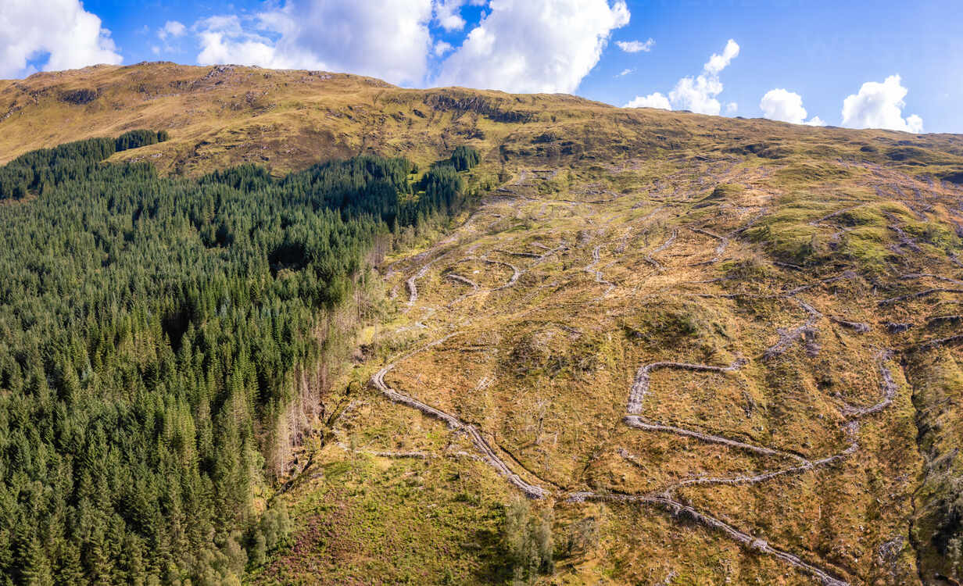
Glen Affric, in the Scottish Highlands. Surviving woodland on the left; on the right, hillside grazed bare of everything that once grew there.
Non Nobis Nati
Born not for ourselves

1. The proposal, in short
I am proposing that St Albans School creates a Grove: a permanent, named collection of native trees, planted and looked after on the School's behalf in the Scottish Highlands by the conservation charity Trees for Life.
A Grove is not a fundraising campaign with an end date. It is a page in the School's name that stays open indefinitely. Anyone connected to the School can add trees to it, and the total only ever goes up. Every £6 donated plants one native tree.
The Grove would do three things at once.
- Take responsibility for the carbon we still produce. The School has already cut what it emits: the new 185 kilowatt solar system completed this summer is expected to save around 30 tonnes of CO₂ every year. Reducing emissions has to come first. But heating, catering, transport and trips remain, and a Grove is a way of answering for what we cannot yet remove.
- Help bring a lost landscape back, not just plant trees. The Great Caledonian Forest once covered much of the Highlands. Around 98 per cent of it has gone from its peak size — not in recent decades, but over thousands of years, and much of it from human choices such as clearance for farming and grazing. Trees for Life is working to restore the whole ecosystem: the trees, the ground beneath them and the wildlife that depends on both.
- Give the School community a concrete action to help tackle climate change. Plenty of people want to act on the climate and nature crises and do not know where to start. £6 and one tree is a place to start, and hundreds of people each giving a little adds up to something none of us could do alone.

What it costs
£24 to create the Grove, plus £6 for the first tree — £30 in total. I will pay this myself and plant the first tree. After that, the Grove is funded entirely by voluntary donations. There is no ongoing cost to the School and no claim on any School budget.

What I am asking the Committee to agree
- Create the Grove in the School's name. Agree in principle that a Trees for Life Grove should be established as "The St Albans School Grove".
- Take it to the Headmaster. Ask the Committee's staff lead to seek the Headmaster's agreement to proceed.
- Approve the launch plan. Agree the launch set out in Section 6 — an assembly, a page on the School website, and articles in School publications and social media channels.
- Own it after launch. Agree that the Eco Committee takes permanent ownership of the Grove, with the serving Chair acting as Grove Steward and a named member of staff holding the account, supported by a pupil Grove Champion — a role I would like to hold while I am at the School.
If the Committee agrees, the Grove page can be live within a week and an assembly ready immediately.

2. What a Grove is, and what it does
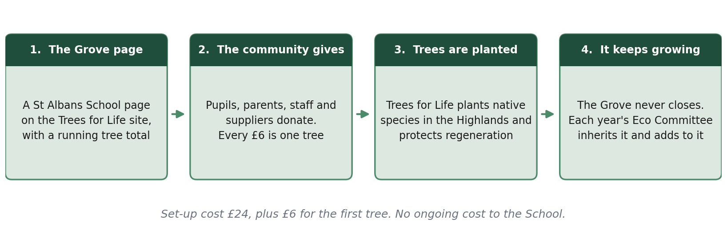
Figure 1: How a Trees for Life Grove works.
Trees for Life gives every Grove its own page on their website. Ours would carry the School's name, a description we write and control, and a live count of trees planted. Anyone can add trees, either as a one-off gift or by monthly Direct Debit, and can leave a short dedication — for a birthday, an exam result, a leaving gift or dedicated to a member of staff. Those dedications appear beneath our description, so the page becomes a public record of who has contributed and why.
Two things are worth being clear about. The School would not own land in the Highlands, and the trees would not be School property: they belong to a restored landscape. And Trees for Life does not label individual trees or put up plaques, because the point is to create a forest that looks and behaves like a forest, not a memorial garden. What the School gets is a permanent, public and independently verified record of what its community has funded.
Trees for Life also chooses which species go where, and whether an area is better served by planting or by protecting natural regeneration. That is a feature, not a limitation — it means each £6 goes wherever it will do most good.

3. Why the School should want to do this

It is already something the School has said it wants to do
The last of the School's published aims commits it to:
“Recognise our wider environmental responsibilities and look to develop sustainable solutions in different areas of school life…”
St Albans School, Ethos, Aims & Values
A Grove is a sustainable solution in an area of school life. It is also one of the few available to a school on a historic city-centre site with very little land of its own. We cannot plant a wood on Abbey Mill Lane. We can fund one in the Great Caledonian Forest.

It is a plain reading of the School's motto
Non Nobis Nati — born not for ourselves. The School already uses the motto to explain why it looks outwards: its Partnership and Community Link page opens by saying the motto “sits at the heart of everything we do”, and that the Partnership programme is fundamental to how the School lives it. A Grove applies the same idea to the environment. It is something the School pays into that benefits people and places entirely outside it, and that will outlast everyone who starts it. The trees planted in the first year will still be growing when September's new First Form are grandparents.

It builds on what the School has already started
In June 2026 the School completed a 185 kilowatt solar installation, which it described as a significant milestone in its commitment to sustainability. It is expected to reduce the School's CO₂ by around 30 tonnes a year. That work matters, and it should come first: it is always better to avoid an emission than to offset it.
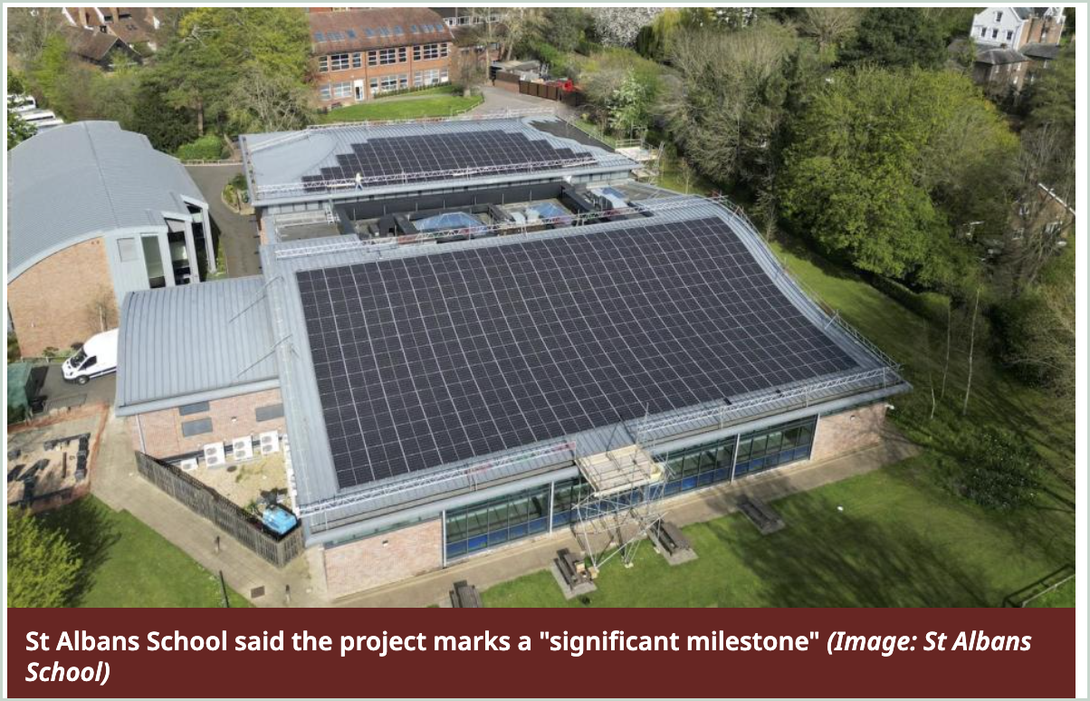
Figure 2: The School's new 185 kW solar installation, completed June 2026. Image: St Albans School, via the Herts Advertiser.
But solar does not reach everything. Heating, catering, transport and school trips all remain, and a Grove is how we answer for the part we cannot yet remove.
Alban City School took exactly this order of steps, and their published figures show why the second step is needed. They already buy renewable electricity and have solar panels on the roof — and their net emissions are still around 35 tonnes of CO₂ a year, almost all of it gas. Cutting emissions gets you a long way. It does not get you to zero.

Trees are already being planted in our name
While researching this I found something I had not expected. STC Expeditions, the school expedition company, has run a Trees for Life Grove since it began a partnership with the charity, and plants a tree for every client who travels with them. Their Grove now holds 2,149 trees.
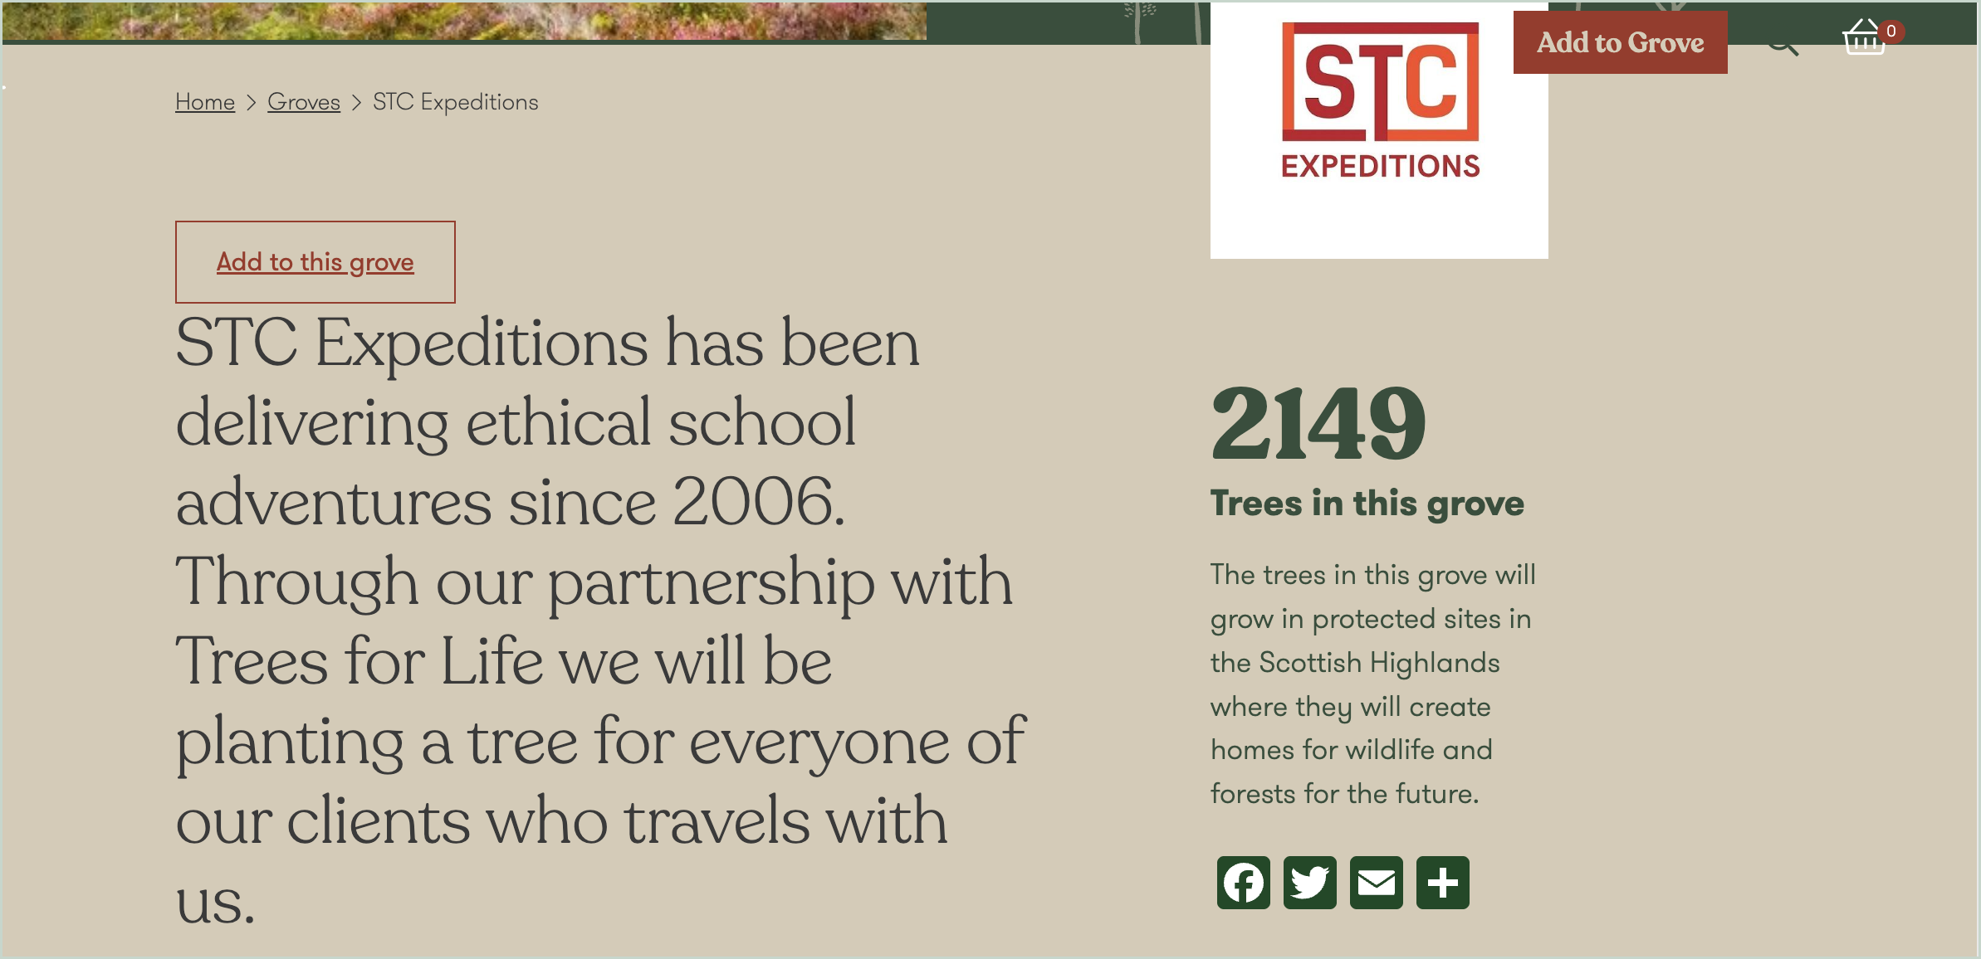
Figure 3: The STC Expeditions Grove — a tree planted for every client who travels with them.
One donation on their page, of 582 trees in November 2025, lists the schools those trees were planted for. St Albans is among them, alongside Charterhouse, Oundle, Reeds, Exeter and Downside. In our case the trees came from the Geography department's trip to Morocco — a popular trip, and one for which the provider calculated the emissions and offset them.
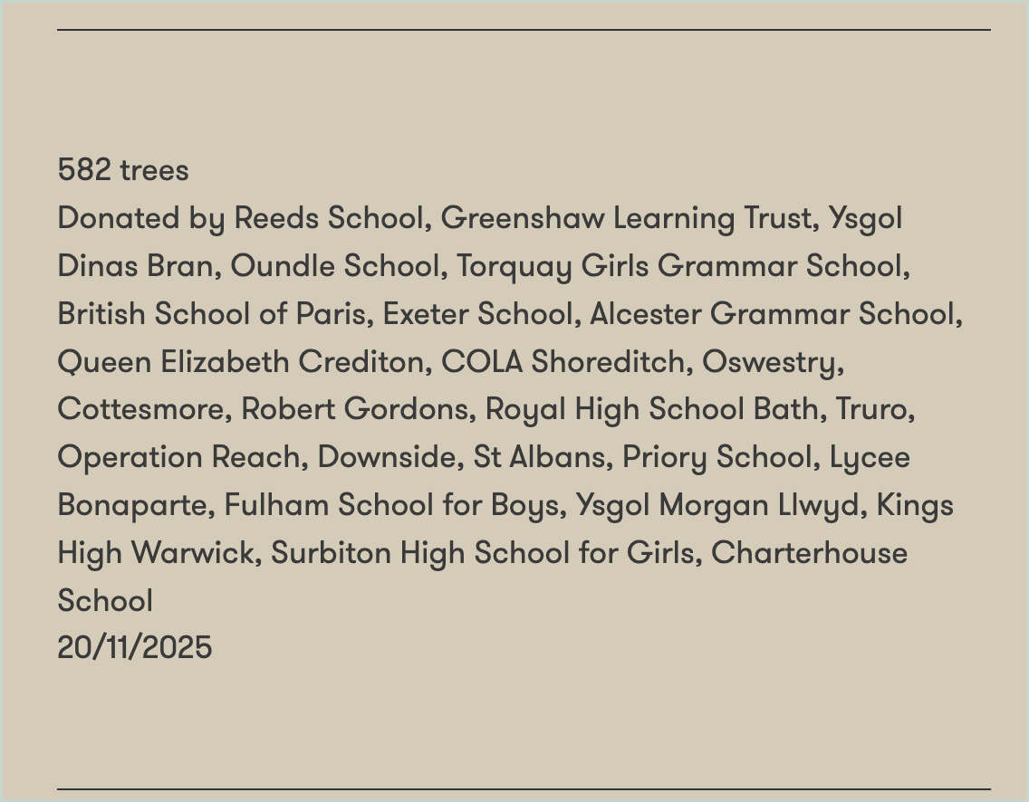
Figure 4: The November 2025 donation to the STC Expeditions Grove. St Albans appears in the list of schools.
So trees have already been planted in the Caledonian Forest on the School's behalf, and the School is already named in a Grove — but as a note referencing St Albans on someone else's page, among a list of other schools. The link exists. The proposal is that we make it our own: deliberate, in the School's name, on a page we control, and with the credit and the responsibility sitting with us.

It mobilises the Eco Committee behind an impactful initiative
We do not currently know what the School's emissions are. I think establishing that should be part of this proposal rather than an afterthought, and it is perhaps an activity for the Committee rather than me:
- collect the School's annual gas and electricity consumption from the Bursary;
- convert it into tonnes of CO₂ using published conversion factors;
- set the Grove's target from that figure, rather than from a round number that sounds impressive.
Alban City School has done exactly this, and published the working. Their net annual consumption comes to 35 tonnes of carbon. Trees for Life's figures suggest every five trees in a Grove save about a tonne over their lifetimes, so 35 tonnes needs 175 trees a year — and 175 trees a year is now their target. It is arithmetic a Maths set could check in a lesson, and it turns a vague ambition into a number. It would be worth doing whatever we decide about the Grove.

It gives us continuous evidence for the Green Flag
The School already displays the Eco-Schools accreditation. A Grove produces a steady stream of exactly the evidence Eco-Schools asks for — pupil-led action, measurable outcomes, community involvement and year-on-year continuity — rather than a one-off project written up once and forgotten.

It brings in people the School does not usually ask
Pupils and parents are the obvious contributors. But a Grove also lets departing pupils and staff be marked with a tree rather than a card, and gives the School a straightforward invitation to put to its suppliers: if you cater for us, drive our buses or run our IT, offset a share of it here.

4. Why Trees for Life, and why Scotland
I looked at several ways a school could fund tree planting. I am recommending Trees for Life for four reasons.

1. It is a British project under British governance
Trees for Life is a registered Scottish charity (SC021303) and a company limited by guarantee, founded in 1989. Its accounts are public. It works in Glen Affric in partnership with Forestry and Land Scotland, a Scottish Government agency. Nobody has to take an overseas carbon-credit broker's word for anything: the trees are in Britain, on land whose management is a matter of public record, and we can go and look at them.

2. Our trees would join the largest rewilding landscape in Britain
Trees for Life is a founding partner in Affric Highlands, a rewilding initiative covering more than 200,000 hectares from Glenmoriston to Kintail, delivered with Rewilding Europe. It won an RSPB Scotland Nature of Scotland Award in 2025. This matters because a hundred trees on their own are a gesture; a hundred trees inside a 200,000-hectare restoration programme are part of something that changes a landscape.
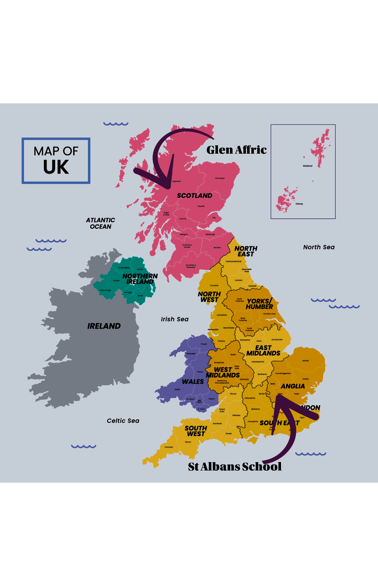
Figure 5: From St Albans to Glen Affric — where the School's trees would grow.

3. It is Britain's most damaged great forest
Seven thousand years ago the Great Caledonian Forest covered around 1.5 million hectares of the Highlands — Scots pine alongside oak, birch, rowan and aspen, with wolves, bears and lynx in it. Centuries of clearance for timber and grazing, and then artificially high deer numbers that eat every seedling, have reduced it to fragments. Only 1 to 2 per cent survives.
It is often called the Amazon of the UK, and the comparison is more exact than it sounds. Around a fifth of the Amazon rainforest has been cleared. In the Highlands the figure is closer to 98 per cent. That is not a reason to care less about the Amazon; it is a reason to notice that the most proportionally devastated great forest of this kind is in Britain, and that it is the one we can act on directly.
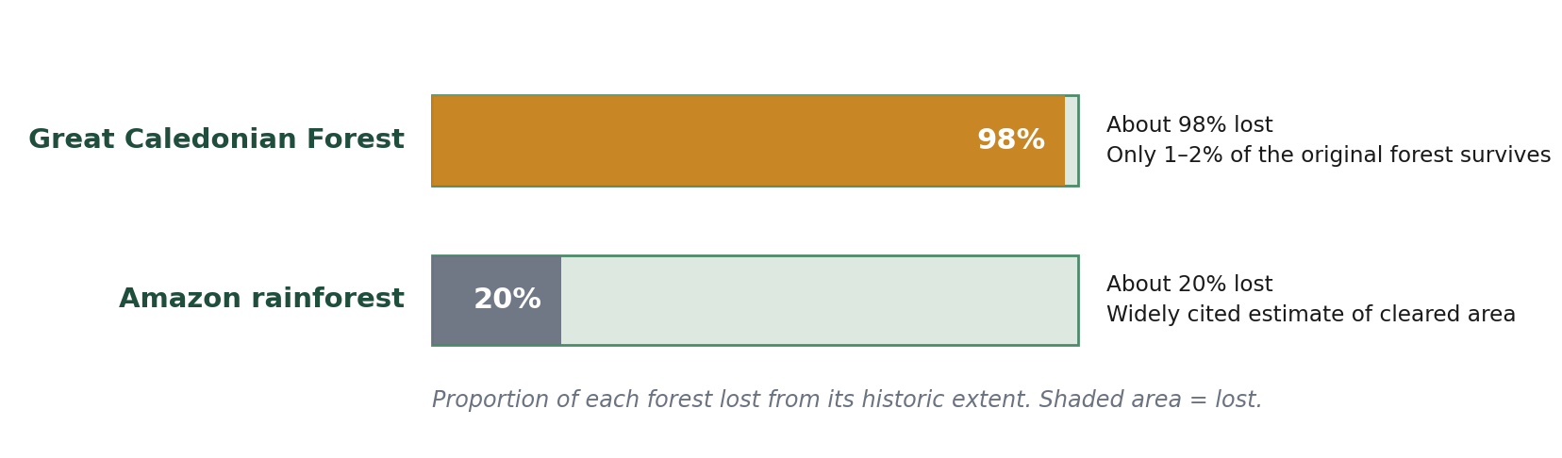
Figure 6: The Caledonian Forest has lost a far greater share of itself than the Amazon.
This is also why Trees for Life rather than a general tree-planting appeal. Their work is deer management and fencing so seedlings survive, planting broadleaves that are missing from pine-dominated glens, and returning species — they have translocated red squirrels, and reintroduced beavers to Glen Affric with Forestry and Land Scotland. Planting trees is one part of restoring a forest, not the whole of it.

4. Every pound goes further
At £6 a tree, Trees for Life is markedly cheaper than the alternatives I could find. £600 raised by the School buys 100 trees here; the same money buys 60 at the National Trust's suggested minimum of £10 a sapling.
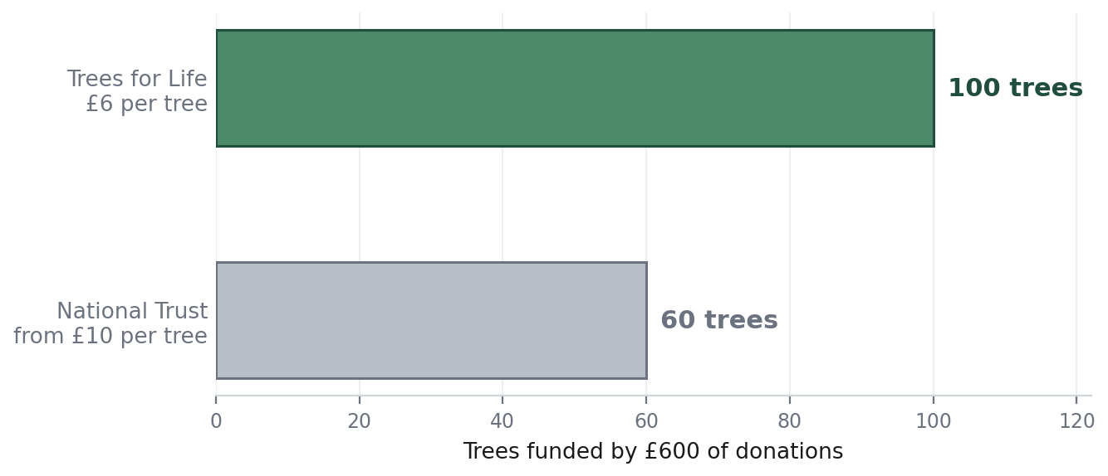
Figure 7: What £600 of donations buys.
Cost is not the only difference, and the others matter more:
 | Trees for Life | National Trust | Woodland Trust
Cost per tree | £6 | From £10 (suggested minimum) | Gift dedications priced per dedication, not per tree
Can be counted as offsetting | Yes — Groves are used for exactly this | No — the Trust states donations do not count towards offsetting your emissions | No — aimed at gifts and memorials
Open to an organisation | Yes — school and corporate Groves are a standard option | No — online tree donations are accepted from individuals only | Donations go to site care and to the Trust's other woods
Shared page with a live total | Yes | No | No
The National Trust's own guidance is the clearest illustration. It will not accept organisational donations for tree planting linked to carbon offsetting, it states plainly that a donation cannot be counted against your own emissions, and it does not tag trees or provide a shared page. For what we want — an organisational, offset-linked, publicly trackable Grove that anyone can add to — Trees for Life is not only the cheapest option. It is one of very few that offers it at all.

Why not plant closer to home?
This was the first question I asked myself, and it is the one the Committee should press hardest. Heartwood Forest at Sandridge seemed the obvious local candidate, so I looked into it.
The Woodland Trust took Heartwood into its care in 2008 and, with volunteers, local people and supporters across the UK, planted more than 600,000 trees there, completing the planting in 2019. It is now the largest new native forest in England. It is also finished. The appeal page still asks for donations, but for keeping the wood open and cared for, and for the Trust's thousands of other woods — not for planting more trees at Heartwood. In 2010 it would have been the perfect project for a St Albans school to join. In 2026 there is no planting there for us to fund.
That is not a criticism of Heartwood. It is a young forest four miles from the School that anyone can walk in, and it should be visited and valued. But if the question is where the School's money plants trees, the answer is no longer Sandridge.
The honest cost of choosing Scotland is that we cannot walk to it. Against that: Trees for Life's Dundreggan Rewilding Centre is open to visitors and has trails through both planted and naturally regenerating woodland, and the charity runs volunteer Rewilding Weeks. A Sixth Form, Geography or Duke of Edinburgh expedition could reach it. And nothing in this proposal stops the School doing local environmental work as well — it is not either/or.

5. It already works: Alban City School
Alban City School, a primary school in St Albans, created a Grove on 20 May 2020 to offset the gas it could not stop burning. It is called “Alban City School – Offsetting our Environmental Impact”. Six years later it is still going, and it is the reason I am confident this works rather than just hoping it might.
It is also not a distant example. Alban City is one of the primary schools in St Albans School's Partnership programme: its pupils come here for lessons in facilities their own school does not have, such as our science labs, and our teachers go to them. A number of pupils here went to Alban City before coming to St Albans, and I am one of them. So this is not a case study from another part of the country. It is a school we already teach in, doing something we could do at a much larger scale.
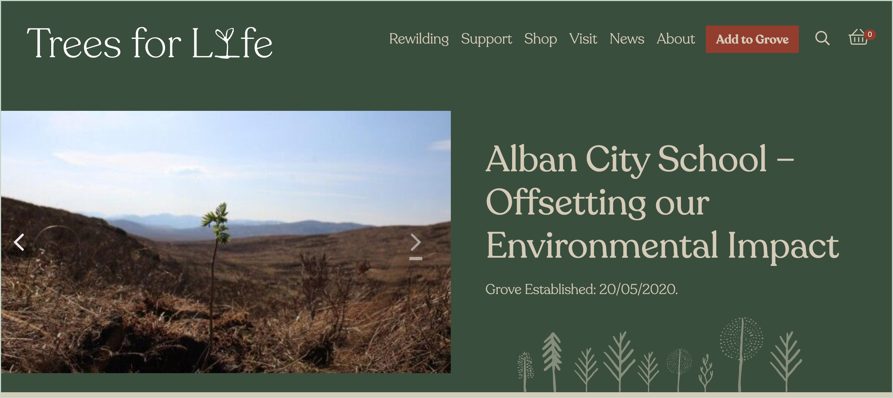
Figure 8: The Alban City School Grove page. The photograph is a single young tree on bare Highland hillside — which is the whole problem in one image.
Their description of why they did it is worth reading in full, because it is not written in the language of a policy document:
“Part of Alban City's mission is to ‘provide an environment that puts children's needs at the top of the agenda'. We see that in its widest sense. We want the school to be a sustainable and responsible citizen within our environment… In doing so, we aim to help address the climate crisis, provide habitat for native wildlife, and offset the school's consumption, working towards a zero carbon impact on the environment.”
Alban City School Grove page, Trees for Life
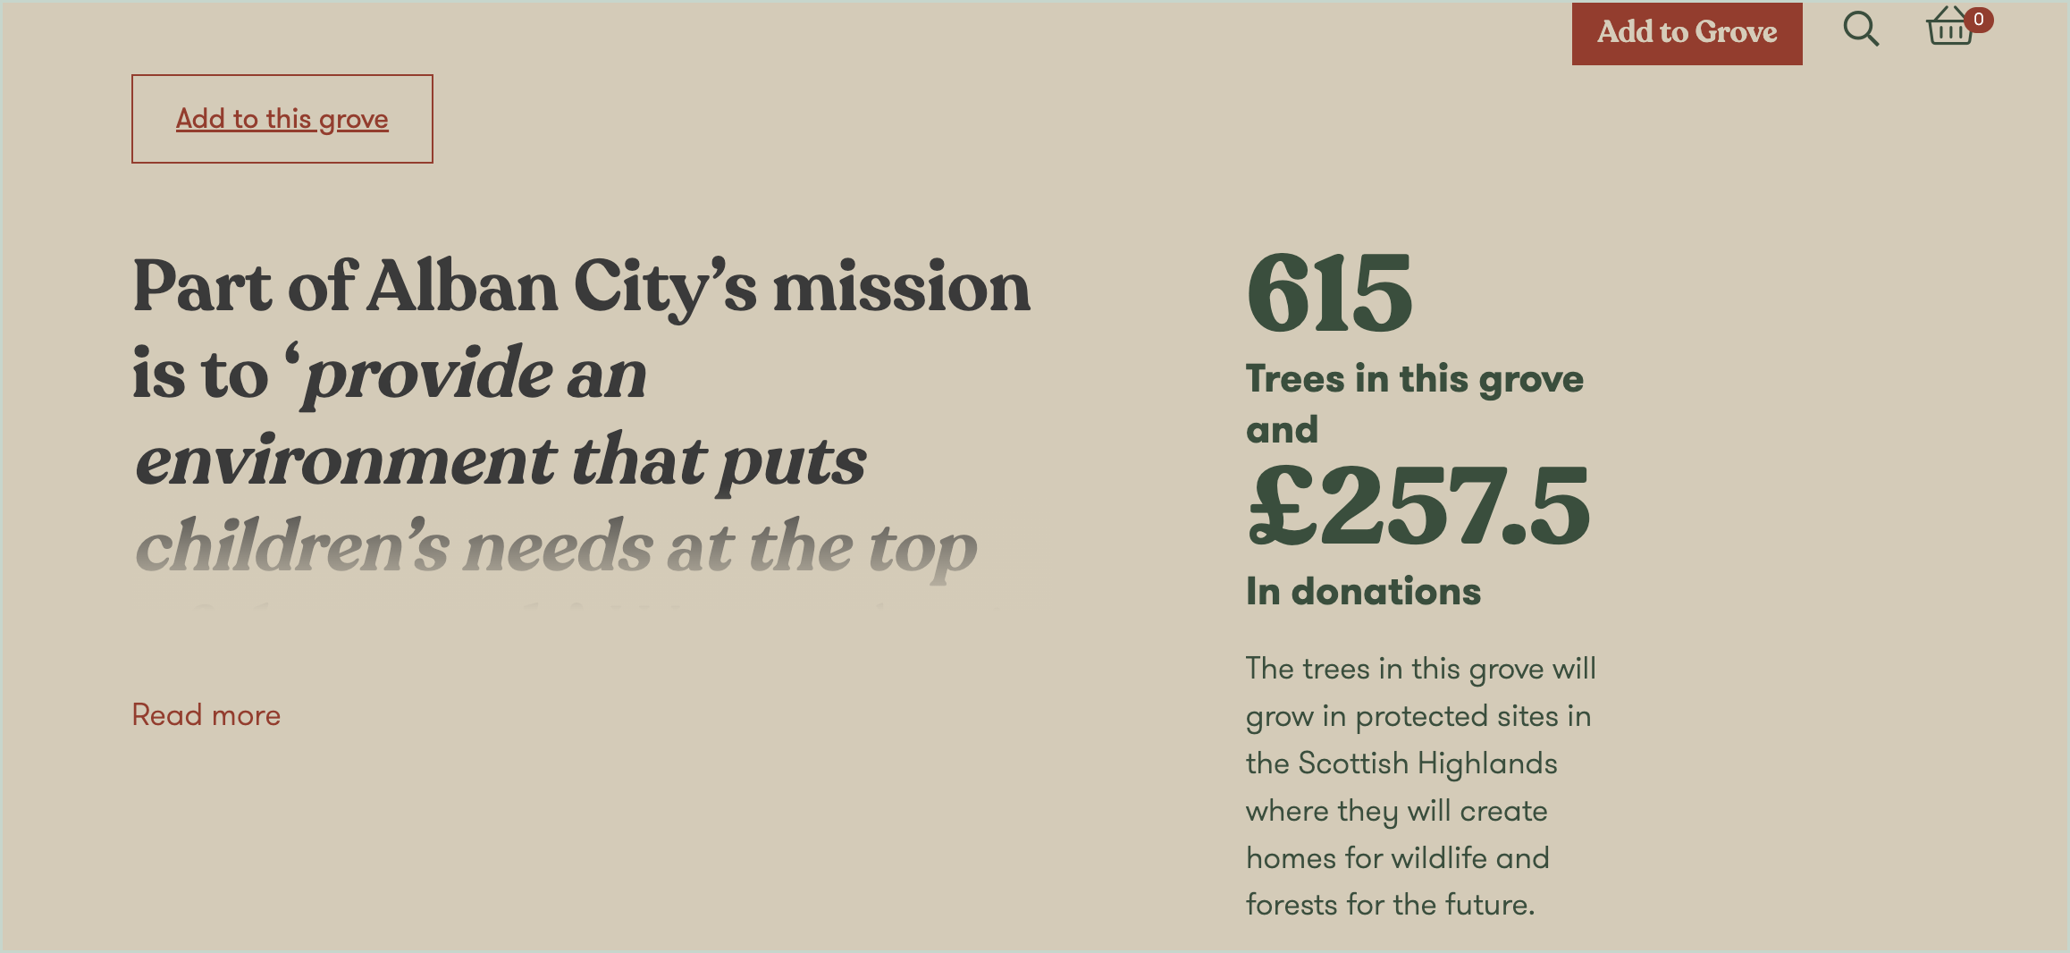
Figure 9: 615 trees, plus £257.50 given towards Trees for Life's wider running costs, as at July 2026.
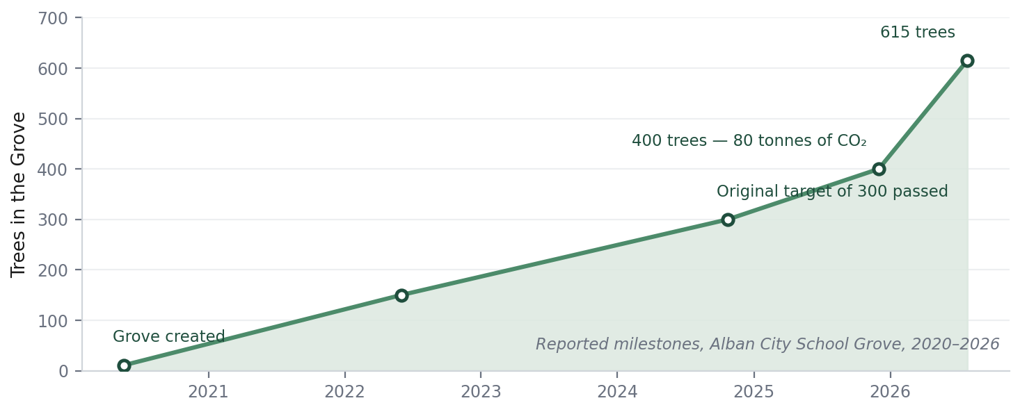
Figure 10: The Alban City School Grove, 2020 to 2026.
The Alban City School Grove at a glance
- Established 20 May 2020. Original target: 300 trees.
- 400 trees by December 2025 — an estimated 80 tonnes of CO₂ saved. 615 trees by July 2026, plus £257.50 donated towards Trees for Life's wider running costs.
- Already buys renewable electricity and has solar panels, so gas is its main remaining source. Net annual consumption: about 35 tonnes of carbon.
- Current target: 175 trees a year — the number needed to offset 35 tonnes, at roughly five trees per tonne over their lifetimes.
- Stated goal: “working towards a zero carbon impact on the environment”.
- Funded entirely by voluntary giving: standing monthly donations from a handful of families, class sponsored runs, craft sales, birthday gifts and dedications from grandparents and family friends.
Two things stand out to me.
- The sums are small. Most entries on the page are one or two trees. The Grove was not built by large gifts; it was built by a lot of people giving very little, repeatedly, for six years.
- It stopped depending on anyone in particular. It has survived every cohort of pupils and parents that started it moving on. That is the test this proposal has to pass too, and it is why Section 6 spends more time on ownership than on the launch.
See it for yourself: the Alban City School Grove

What I would do differently
St Albans is a much larger school, with a House system and its own suppliers, so we can raise more and from more directions. I would set our target from a measured emissions baseline rather than adopting a round number. And I would build the annual handover in from the start, together with a standing pupil role to keep the Grove visible, rather than discovering later that both were needed.
Most of all, I would lead with regular giving rather than events. At Alban City the steady growth in the chart above comes mostly from a small number of families giving every month, not from the fundraising days. £6 a month is one tree a month, twelve trees a year, and it arrives whether or not anyone remembers to organise anything. Set against the cost of school fees it is a very small amount, and it is a more realistic ask to make of our parent body than of a school whose families' circumstances vary far more widely. Fifty monthly donors at £6 would fund 600 trees a year on their own — almost as many as Alban City has planted in six years.

6. How it would work

Launch: the first half-term
- Create the Grove page and write its description with the Committee. I pay the £30 and plant the first tree.
- An assembly, given by the Committee, on the Caledonian Forest and what the Grove is for.
- A page on the School website under Sustainability, with the live tree count and a link.
- An article in School publications introducing the Grove and how to add a tree to it.
- Formal handover of ownership to the Eco Committee at the end of the launch half-term.

Keeping it going: possible activities through the year
These are suggestions rather than a programme. The point is that something happens in each term, so the Grove never goes quiet for a whole year — but the Committee should choose what actually fits the calendar, drop anything that does not work, and add ideas of its own. Some of the best fundraising at Alban City was things nobody planned in advance.
When | What | Purpose
Autumn Term | Assembly and target announcement | The Committee reports last year's total and sets this year's target.
Autumn Term | House competition | Houses compete over a term to fund the most trees. Small sums, high participation.
Spring Term | Sponsored event or craft sale | One pupil-led fundraising event, run by the Committee.
Summer Term | Leaving gifts and dedications | Trees to mark leaving Fifth Form and Upper Sixth, and as end-of-year gifts for staff.
Summer Term | Annual review | Standing item at the final Committee meeting: report the total, hand over to the incoming Chair.
Ongoing | Website counter and School publications | A live total on the School site, and an article each year reporting where the Grove has got to.

Ownership, and my part in it
This is the part that decides whether the Grove is still growing in ten years, so I want to separate two things that are easy to confuse: who owns the Grove, and who pushes it along.
The Grove belongs to the School, not to me. It should be owned by the Eco Committee from the launch onwards, and nothing about it should ever require my permission or my presence. If it could not survive me leaving, it has been built wrong.
Ownership and enthusiasm are not the same thing, though. For as long as I am at the School I would like to be the Grove's champion — writing pieces for School publications and social media, speaking in assemblies, helping the Committee run events and dedications, keeping an eye on the total, and reporting to the Eco Committee whenever that is useful. I care whether this works and whether it has real impact, and I would rather stay useful than set it up and walk away. When I do leave, I want the Committee not to notice.
In practice:
- The Eco Committee owns it. The serving Chair holds the role of Grove Steward, written into the Chair's remit so it passes automatically each year. Decisions about targets, events and how the Grove is described are the Committee's.
- A member of staff holds the account. A named member of staff — the Sustainability lead, or the Head of Geography or Biology — keeps the login and the institutional memory, so nothing is lost between cohorts.
- It is a standing agenda item. The final Committee meeting of each year reports the total and sets the next target.
- A pupil Grove Champion supports it. A promotional role, not a governing one: publicity, fundraising energy, keeping the Grove visible. It carries no authority over the Grove and can sit vacant without anything breaking. I would like to hold it while I am here, and I would like the Committee to offer it to another pupil each year afterwards — the School's own Partnership page notes that this kind of voluntary work helps pupils “develop some of the vital skills relevant for future employment and UCAS applications”, and a standing pupil role does that for whoever holds it.

Targets
I have deliberately not proposed a headline number, because a target that is not derived from anything is just a slogan. I suggest a nominal initial target of 100 trees in the first year — requiring £600 of donations — with a more considered annualised target set by the Committee once the emissions baseline in Section 3 is known.

7. What it gives us in lessons
The Grove is useful in the classroom because it is real, local to us in the sense that we paid for it, and it changes every year.
- Geography. A live case study in rewilding, land management, deer pressure and ecosystem restoration, in a British landscape rather than a textbook biome.
- Biology. Succession, keystone species and trophic cascades, with the Glen Affric beaver reintroduction as a current example rather than a historical one.
- Maths and Economics. The emissions baseline is a genuine modelling exercise: consumption to tonnes of CO₂, cost per tonne abated, and the difference between offsetting and reducing.
- EPQ and independent research. For example: does micro-philanthropy provide a sustainable funding stream for landscape-scale restoration? Or, how should a school choose between offsetting and reducing a tonne of carbon?
There is also a direct link to School trips. As Section 3 sets out, STC Expeditions already plants trees with Trees for Life for every client who travels with them, and St Albans appears in their Grove. The School could extend the same principle to the travel it arranges itself — and a Geography or Economics class could work out what that would cost per pupil per trip, which is a more interesting exercise than it sounds.

8. Risks
Risk | Likelihood | How we handle it
It is forgotten once the launch excitement passes | Medium | This is the main risk. It is handled by the annual rhythm in Section 6 and by making the Grove a standing Committee agenda item, not by good intentions.
It depends on one person and stops when they leave | Medium | Ownership sits with the Committee and a named member of staff from the launch onwards. The Champion role is deliberately separate from ownership, and can be left vacant or passed to another pupil without affecting the Grove.
Families feel asked for money too often | Medium | Giving is always voluntary and never named or compared. We keep the asks small and infrequent, favour events over direct appeals, and bring in Old Albanians and suppliers so the same families are not the only source.
It looks like the School buying its way out of reducing emissions | Low | The Grove is presented as second to reduction, never as a substitute. The emissions baseline work makes that order explicit and measurable.
Trees for Life turns out to be a poor partner | Low | A 30-year record, public accounts, over two million trees planted, and delivery in partnership with a Scottish Government agency. The Committee reviews the partnership annually.

9. The decision I am asking for
I ask the Eco Committee to agree:
- that a Trees for Life Grove be created in the School's name, as “The St Albans School Grove”;
- that the Committee's staff lead seek the Headmaster's agreement to proceed;
- the launch plan in Section 6; and
- that the Committee takes permanent ownership of the Grove after launch, with the serving Chair as Grove Steward, a named member of staff holding the account, and a pupil Grove Champion supporting it.
I will pay the £30 set-up cost and plant the first tree. The Grove asks nothing of the School's budget.
Every pupil is here for a few years. The Grove would be here for centuries. I would like St Albans School to plant its first tree this term.

Further reading and viewing
- Alan Watson Featherstone: TEDx talk — the founder of Trees for Life on what the Caledonian Forest was and what restoring it would mean. It gives an impactful and much wider view of the charity's aims than this proposal can, and I think it would inspire anyone who watched it. My suggestion is that we show it, or part of it, during the launch assembly.
- Trees for Life — what we do — the charity's own account of its restoration work.
- The Caledonian Forest — history, ecology and what has been lost.
- Affric Highlands — the 200,000-hectare rewilding landscape our trees would sit inside.
- The Alban City School Grove — the local school Grove this proposal is modelled on.
- Learning About Rewilding — the article I wrote when I first started reading about this in 2020.
- Scotland: The New Wild (BBC) — a series on the Highlands and the return of native woodland.
- Dundreggan Rewilding Centre — Trees for Life's visitor centre, open to the public.
- The STC Expeditions Grove — where trees have already been planted for St Albans trips.
- Heartwood Forest, Sandridge — the Woodland Trust's local forest: 600,000 trees, planting completed in 2019.
- St Albans School's solar installation — Herts Advertiser report on the 185 kW system, June 2026.
- The Eco-Schools framework: the Seven Steps — the criteria the Grove would provide evidence against. See Appendix C.
- Eco-Schools Count Your Carbon — a free emissions calculator for schools, for the baseline work in Appendix B.

Appendix A: Trees for Life — verification
Trees for Life is a registered Scottish charity (SC021303) and a company limited by guarantee (SC143304), with registered offices at The Park, Findhorn Bay, Forres, Moray. It was founded in 1989 and has planted over two million trees. Its restoration work in Glen Affric is carried out in partnership with Forestry and Land Scotland, a Scottish Government agency, and it is a founding partner of Affric Highlands (registered Scottish charity SC054153) alongside Rewilding Europe.
Grove costs, as published in July 2026: £24 to create a Grove; £6 per tree thereafter, one-off or by Direct Debit. “School” is one of the standard Grove types offered.

Appendix B: How to work out the School's offset
This is the method I suggest the Committee follows, using Alban City School's approach as the template. Eco-Schools also publishes a free full-scope emissions calculator for schools, Count Your Carbon, which would do most of steps 1 and 2 for us.
- Obtain annual gas and electricity consumption for the School from the Bursary, ideally for the last three years.
- Convert consumption to tonnes of CO₂ using the UK Government's published greenhouse gas conversion factors, treating electricity and gas separately.
- Subtract generation from the new 185 kW solar installation, which the School expects to save around 30 tonnes of CO₂ a year.
- Apply the estimate Alban City uses — roughly five trees sequestering one tonne of CO₂ over their lifetimes — to convert the remaining emissions into a number of trees.
- Set an annual target from that figure, and publish the working alongside it so the number can be challenged.
The worked example we can copy
Alban City School: net annual consumption 35 tonnes of CO₂. At five trees per tonne, that is 35 × 5 = 175 trees a year. So 175 trees a year is their target, and 615 trees to date represents roughly three and a half years of their emissions already accounted for.
St Albans School is much larger, so our number will be bigger — but the arithmetic is identical, and the solar installation has already removed about 30 tonnes a year from it.
The point of publishing the method is that a target nobody can check is not really a target. It also makes the Grove genuinely useful to the Maths and Economics departments.

Appendix C: What the Grove contributes to the School's commitments
A Grove is worth doing on its own terms. But it also does specific work for the School against commitments it has already made publicly, and against expectations the sector is increasingly measured by. I have set these out separately so the Committee can see precisely what £6 a tree buys beyond the trees.

C.1 Commitments the School has already made
Commitment | Where it is stated | What the Grove contributes
“Recognise our wider environmental responsibilities and look to develop sustainable solutions in different areas of school life” | The last of the School's published aims, Ethos, Aims & Values | A permanent, measurable sustainable solution in an area of school life — and one of very few available to a school with almost no land of its own.
Non Nobis Nati — born not for ourselves | School motto. The Partnership page states the motto “sits at the heart of everything we do” | Benefit that accrues entirely outside the School, to a landscape and to generations who will never know the School existed.
Eco-Schools accreditation | Displayed on every page of the School website | Evidence against all seven steps of the Eco-Schools framework — set out in C.2 below.
A “significant milestone” in the School's commitment to sustainability and lowering energy costs | School statement on the 185 kW solar installation, June 2026 | Completes the picture. Solar reduces; the Grove accounts for what reduction cannot reach, and gives the School something to say about heating, catering and travel.
Partnership and Community Link programme with local primary and special schools | School website; programme running for over fifteen years | The model is proven at Alban City, a Partnership school. A shared environmental project extends an existing relationship rather than creating a new one.
Public benefit as a charitable school | Charitable status; public benefit reporting | Environmental stewardship and broad community participation, independently evidenced by a third party, with a specific number attached to it.

C.2 The Eco-Schools Green Flag: all seven steps
The School already displays Eco-Schools accreditation. The Green Flag award is assessed against seven steps. A single Grove produces evidence against every one of them.
Step | What Eco-Schools asks for | What the Grove provides
1 Eco-Committee | A pupil group, supported by staff, meeting regularly, planning and delivering environmental projects and inspiring the wider school community | The Grove is owned and run by the Eco Committee. It gives the Committee a permanent flagship project, a named Grove Steward role, and a standing annual agenda item.
2 Environmental Review | Identify initiatives already taking place, areas for improvement and opportunities for quick wins | The emissions baseline in Section 3 and Appendix B is this exercise, for energy. Eco-Schools' own free Count Your Carbon calculator can be used to do it.
3 Action Plan | Deliver projects across at least three of the ten Eco-Schools topics during the year | The Grove touches four: Biodiversity, Energy, Global Citizenship and Transport — the last through offsetting School trips.
4 Curriculum Links | Link climate change to at least three areas of curriculum learning | Section 7 sets out four: Geography, Biology, Mathematics and Economics, plus EPQ topics.
5 Informing and Involving | Share the work through newsletters, social media, local press or pupil-planned assemblies, and involve schoolmates, staff and families | The activities in Section 6 are built on exactly these channels, and the Grove page lets families take part directly rather than only being told about it.
6 Monitoring and Evaluation | Understand and record the impact created — before and after pictures, graphs and charts, or diary entries | The Grove page is a permanent, independently maintained running total. The chart in Section 5 is what ours would look like in a few years.
7 Eco-Code | A mission statement that acts as a call to action for all | The Grove description the Committee writes, and updates each year, is a published statement of intent seen by everyone who visits the page.
It is unusual for one project to give evidence against all seven steps. That is because a Grove happens to be pupil-led, measurable, permanent and public all at the same time.

C.3 Wider expectations on schools
These are not legal duties on an independent school. They are the direction the sector is travelling in, and the benchmarks that inspectors, prospective families and pupils increasingly apply.
Expectation | Source | Relevance to the Grove
Every education setting to have a nominated sustainability lead and a Climate Action Plan covering “curricular and extra-curricular activity, procurement, adaptation and decarbonisation plans” | DfE, Sustainability and Climate Change strategy | The Grove is a ready-made extra-curricular and community strand of such a plan. The baseline work in Appendix B feeds the decarbonisation part. The staff liaison and Grove Steward roles mirror the leadership model being asked for.
“A better environment for future generations: enhancing biodiversity… and increasing access to, and connection with, nature” | DfE strategy, strategic aim | Native woodland restoration is biodiversity work at landscape scale, and Dundreggan provides a realistic route to physical access for pupils.
Carbon literacy, and understanding emissions reporting, within every setting | DfE strategy | The baseline exercise builds precisely this capability — and builds it in pupils, not only in staff.
Pupil-led action on nature and climate, recognised through schemes such as the National Education Nature Park and the Climate Leaders Award | DfE strategy | The Grove is pupil-initiated, pupil-run, and independently evidenced by a national conservation charity.
None of this is the reason to plant trees in the Highlands. But it does mean the Grove is not a cost the School carries for goodwill alone. It is a very small amount of money and effort that does a disproportionate amount of institutional work.

